# 实验六 **熟悉Hive的基本操作**

|  |  |  |  |  |
| --- | --- | --- | --- | --- |
| **地 点：** | B10楼 | 303房； | **实验台号：** |  |
| **实验日期与时间：** | 2023/4/20 | | **评 分：** |  |
| **预习检查纪录：** |  | | **实验教师：** | 焦青松 |

1. **实验目的**

**(1).理解Hive作为数据仓库在Hadoop体系中的角色**

**(2).熟练使用常用的HiveQL**

1. **实验平台**

(1).操作系统:Linux

(2).Hadoop版本:3.3.5

(3).Hive版本:3.1.3

(4).JDK版本:19.0.2

1. **实验步骤（包括实验结果/截图）**

**Hive的安装**

**解压缩**

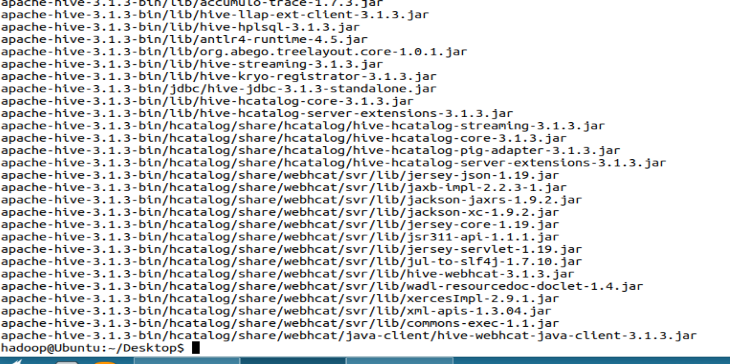

**授予权限**



**配置环境变量**

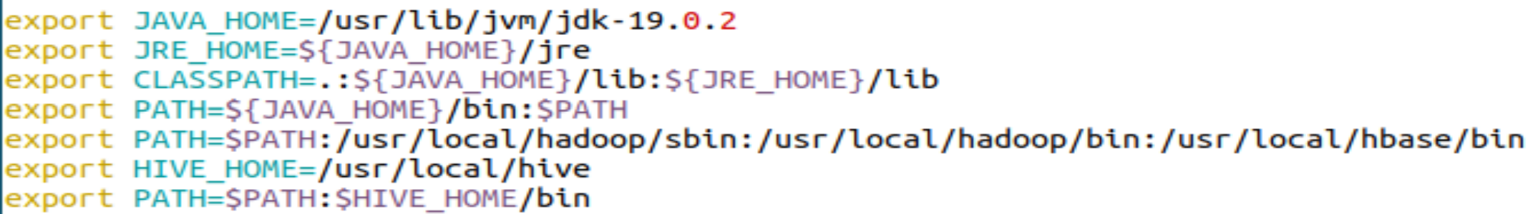



**修改配置文件**

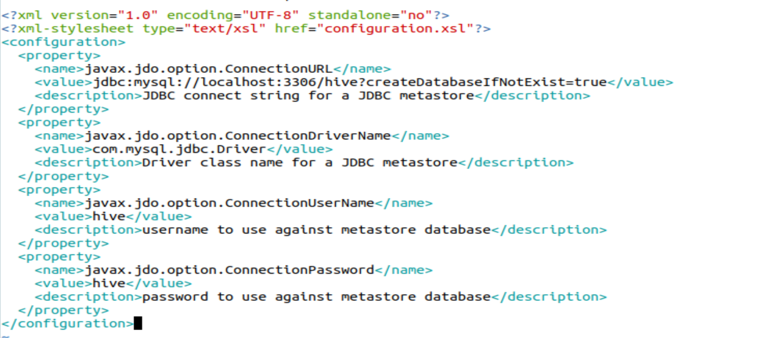

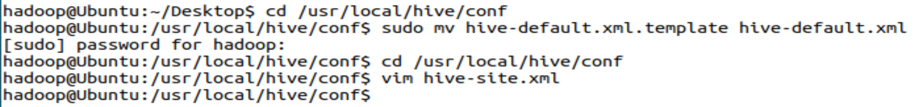

**配置mySQL**

**MySQL在实验4时已经安装，此处不必重新安装。**

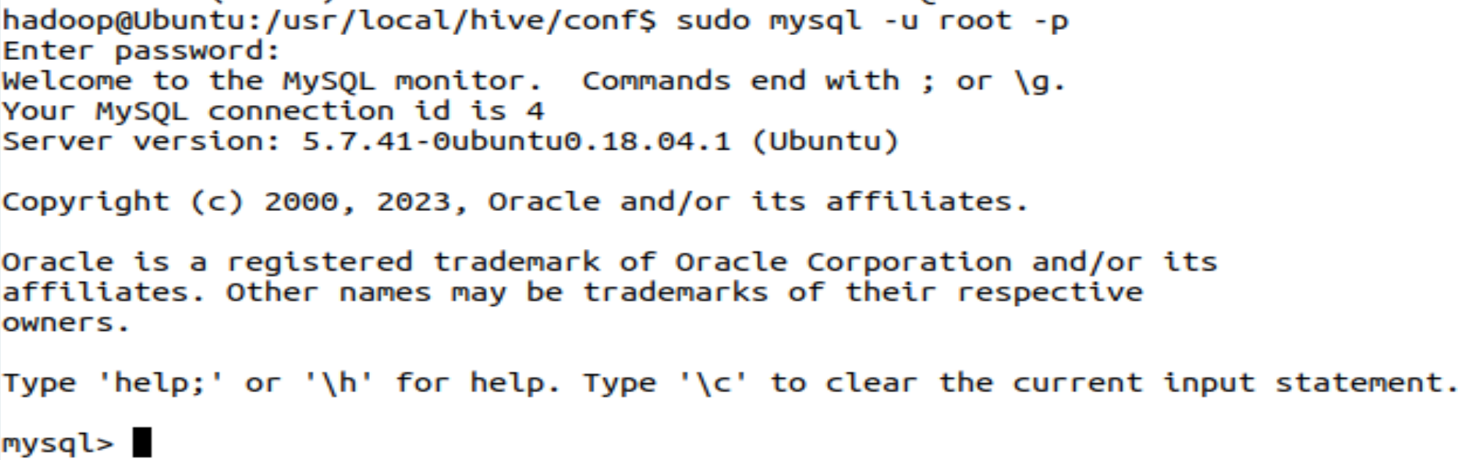

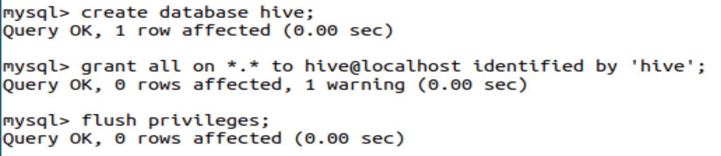

**驱动配置**

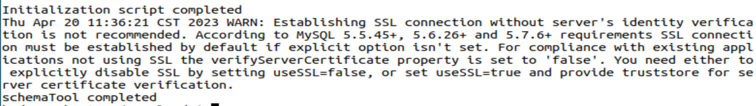

**启动Hive**

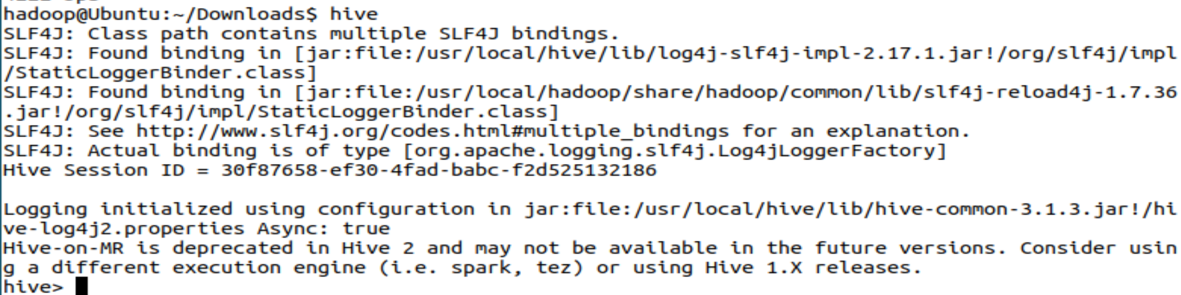

**实验**

**数据集下载，然后解压缩**

**1.创建内部表**

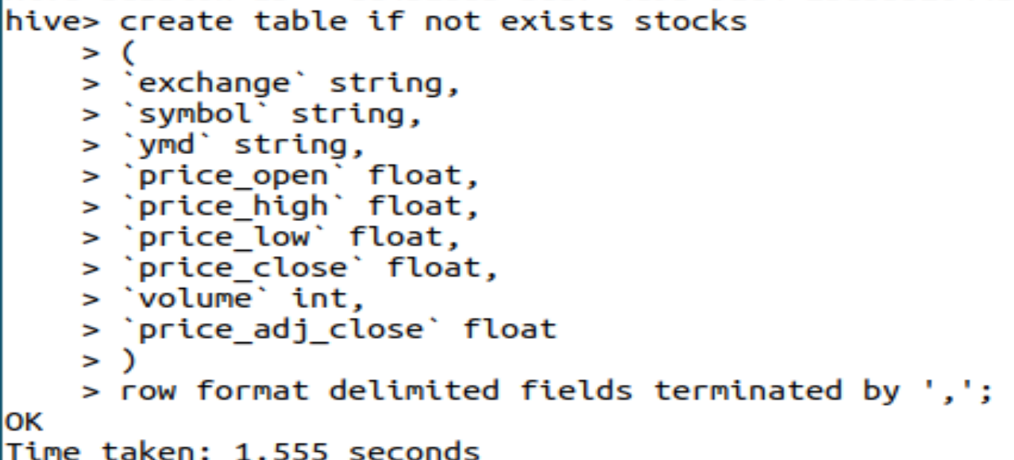

**建表成功**

**2.导入数据**



**3.创建外部分区表**

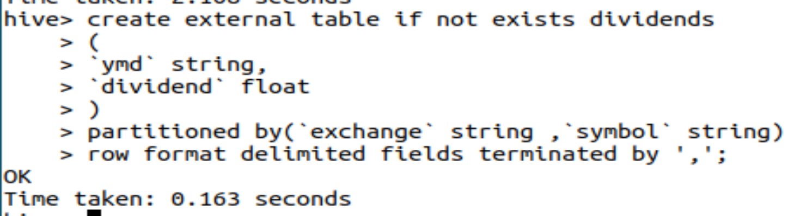

**4.未分区外部表**

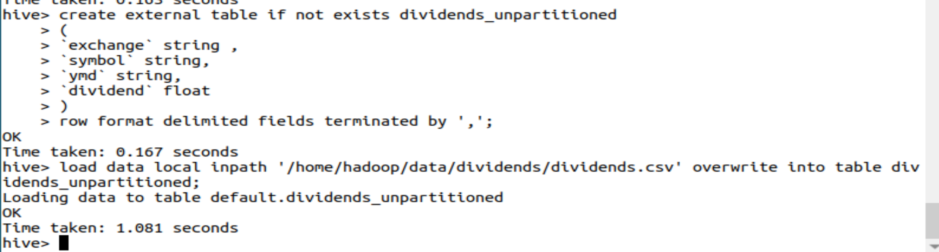

**5.查询语句**

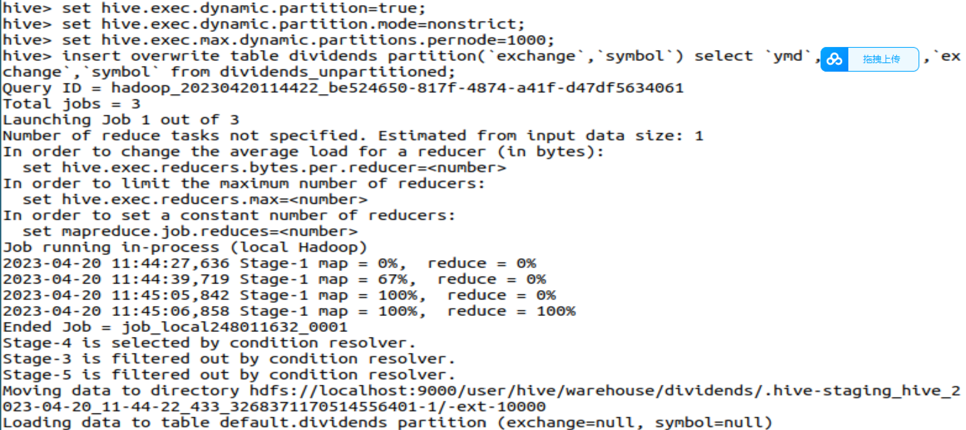

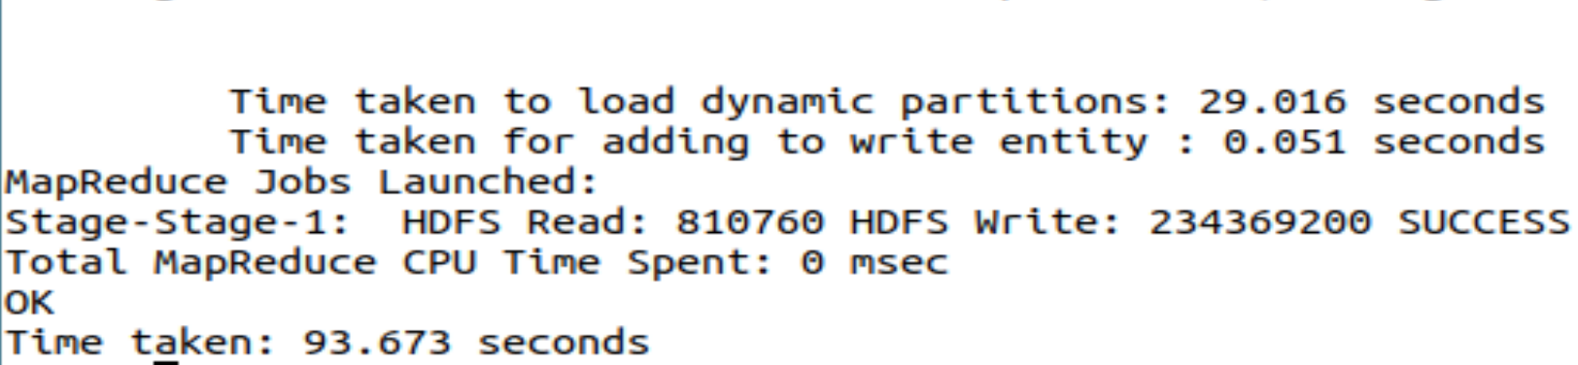

**6.查询收盘价**

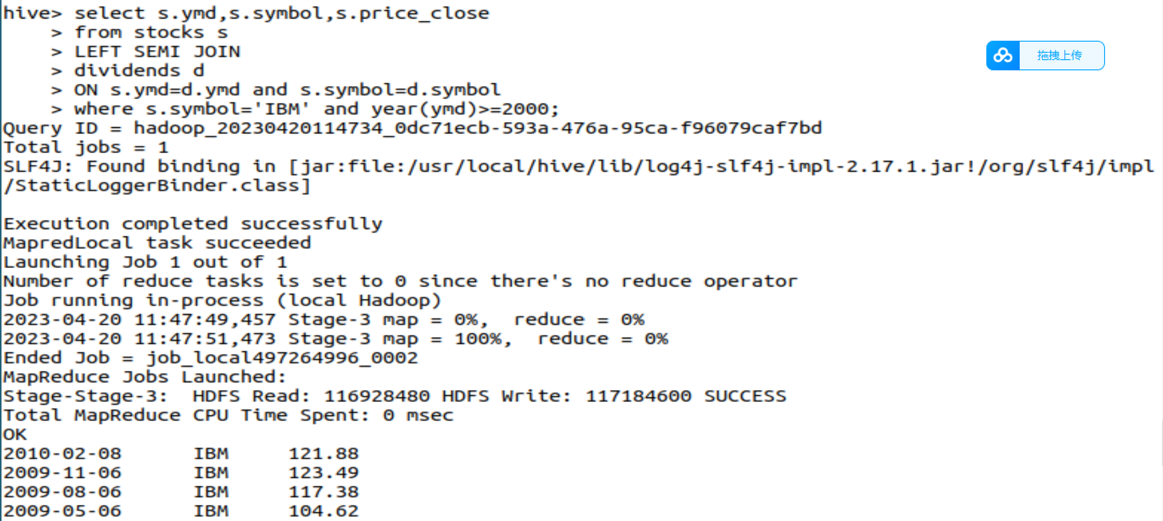

**7.查询苹果公司涨跌情况**

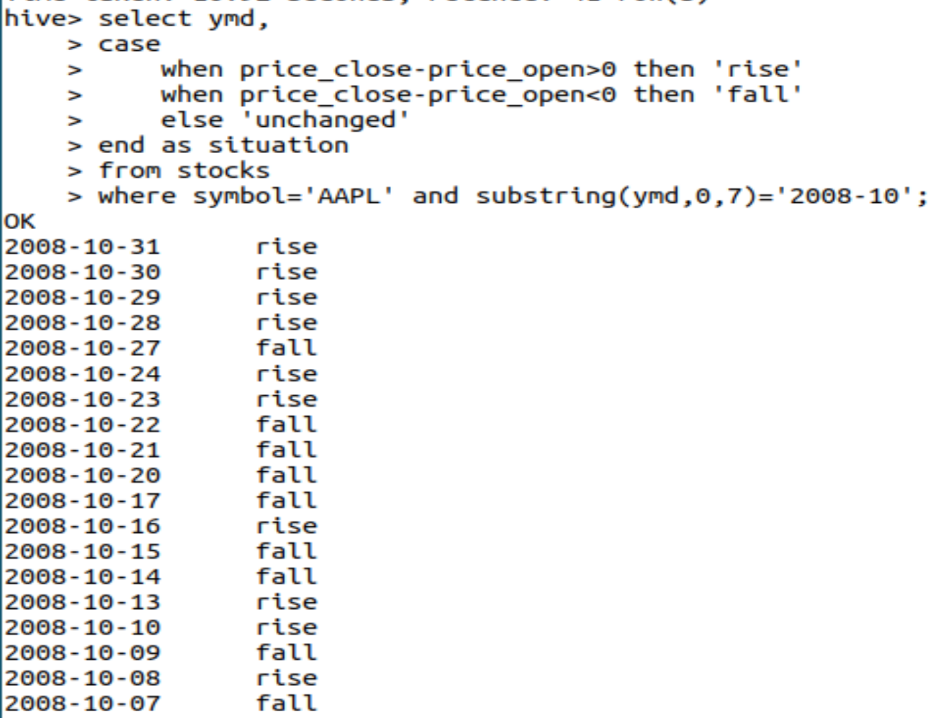

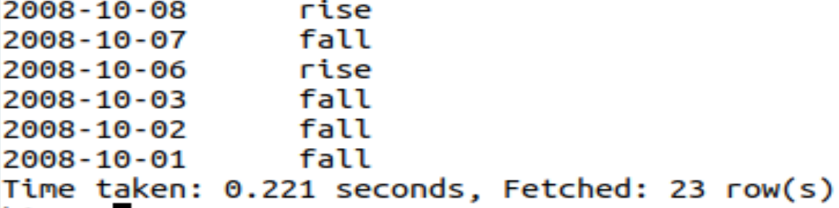

**8.查询差价**

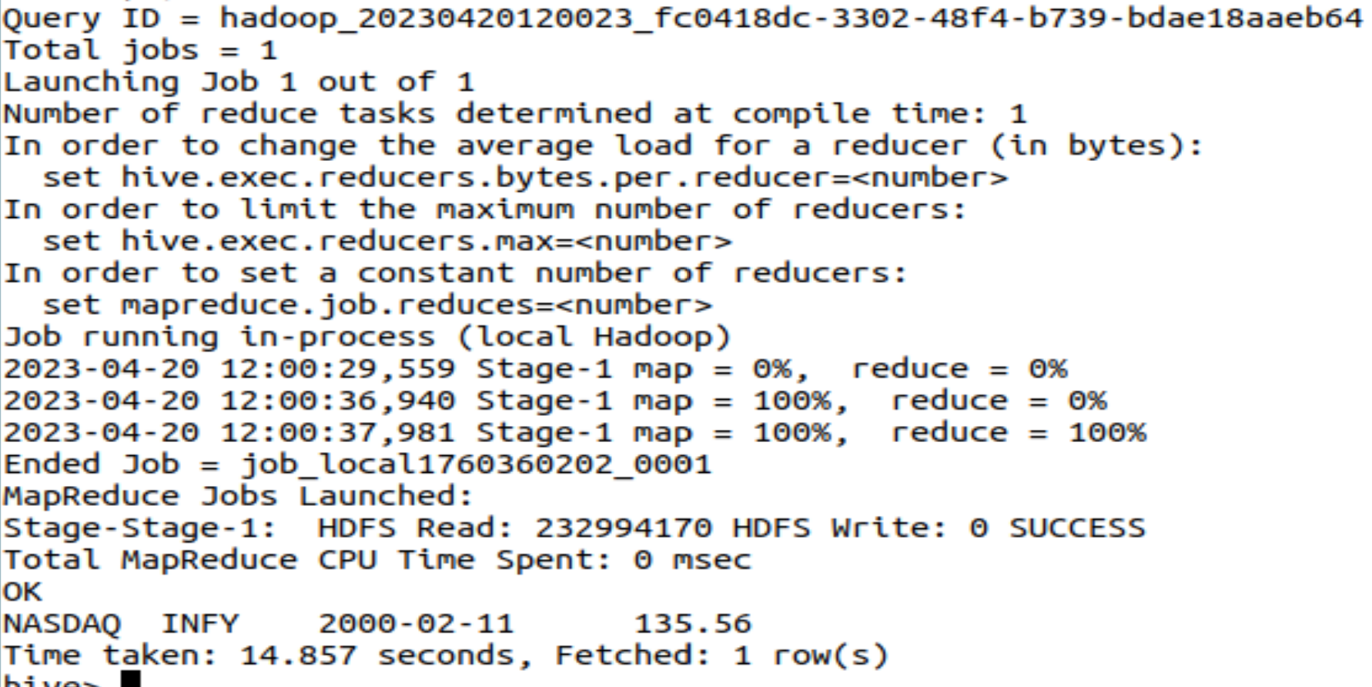

**9.查询收盘价大于50美元**

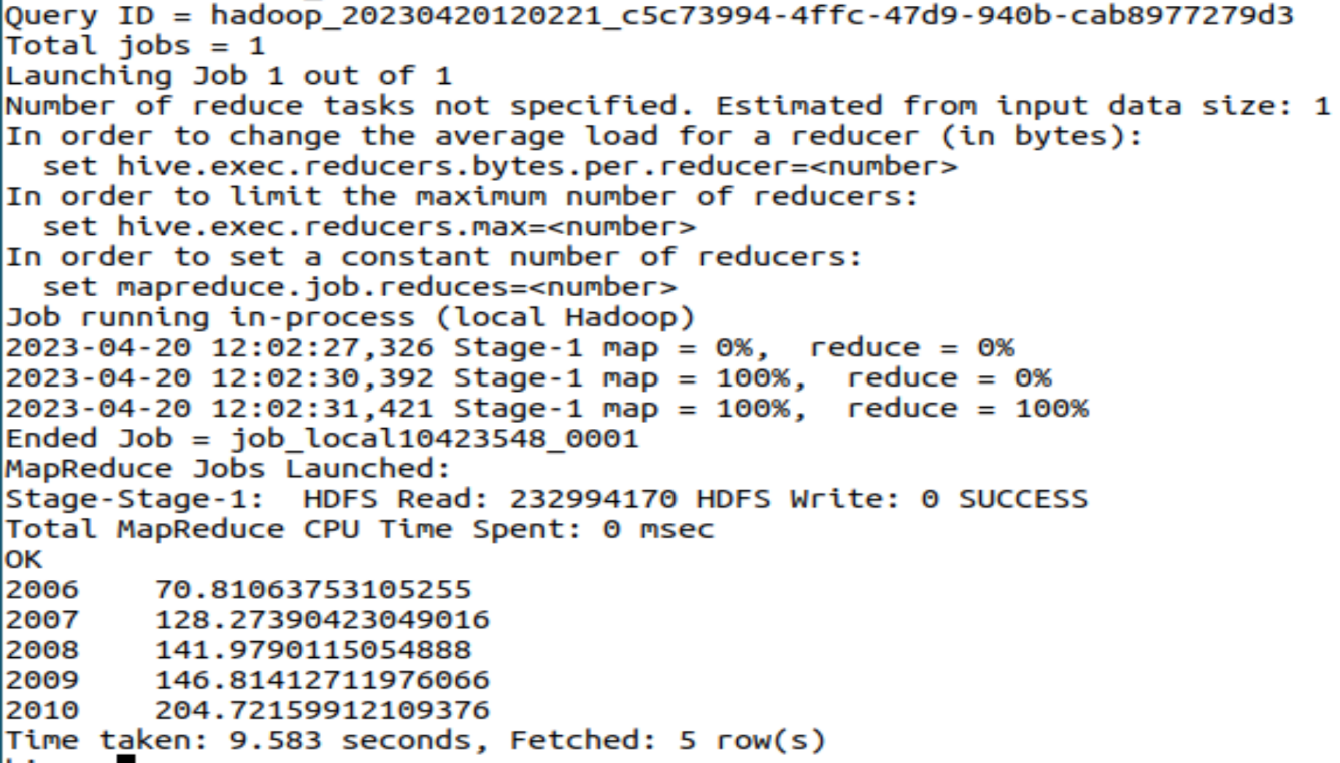

**10.年平均调整收盘价**

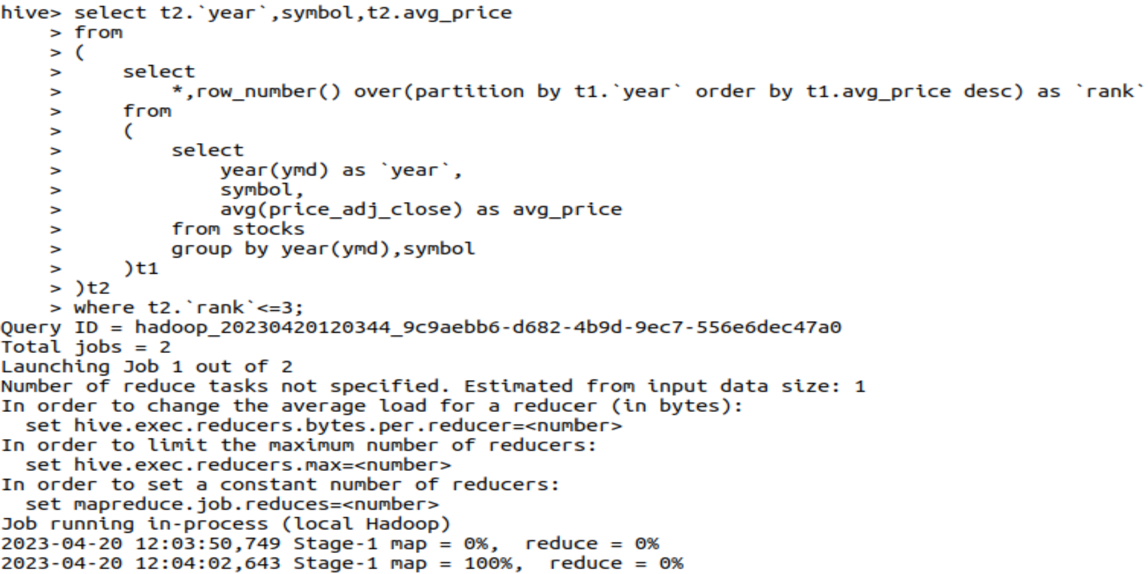

**因内存不足，无法启动。**

1. **思考讨论题或体会或对改进实验的建议**

**HiveQL与之前所学的SQL语言有诸多不同，这一点需要注意。**

1. **实验源代码**

**sudo tar -zxvf ./apache-hive-3.1.2-bin.tar.gz -C /usr/local # 解压到/usr/local中**

**cd /usr/local/**

**sudo mv apache-hive-3.1.2-bin hive # 将文件夹名改为hive**

**sudo chown -R hadoop:hadoop hive # 修改文件权限**

<?xml version="1.0" encoding="UTF-8" standalone="no"?>

<?xml-stylesheet type="text/xsl" href="configuration.xsl"?>

<configuration>

<property>

<name>javax.jdo.option.ConnectionURL</name>

<value>jdbc:mysql://localhost:3306/hive?createDatabaseIfNotExist=true</value>

<description>JDBC connect string for a JDBC metastore</description>

</property>

<property>

<name>javax.jdo.option.ConnectionDriverName</name>

<value>com.mysql.jdbc.Driver</value>

<description>Driver class name for a JDBC metastore</description>

</property>

<property>

<name>javax.jdo.option.ConnectionUserName</name>

<value>hive</value>

<description>username to use against metastore database</description>

</property>

<property>

<name>javax.jdo.option.ConnectionPassword</name>

<value>hive</value>

<description>password to use against metastore database</description>

</property>

</configuration>

create table if not exists stocks

(

`exchange` string,

`symbol` string,

`ymd` string,

`price_open` float,

`price_high` float,

`price_low` float,

`price_close` float,

`volume` int,

`price_adj_close` float

)

row format delimited fields terminated by ',';

create external table if not exists dividends_unpartitioned

(

`exchange` string ,

`symbol` string,

`ymd` string,

`dividend` float

)

row format delimited fields terminated by ',';

load data local inpath '/home/hadoop/data/dividends/dividends.csv' overwrite into table dividends_unpartitioned;

select s.ymd,s.symbol,s.price_close

from stocks s

LEFT SEMI JOIN

dividends d

ON s.ymd=d.ymd and s.symbol=d.symbol

where s.symbol='IBM' and year(ymd)>=2000;

select ymd,

case

when price_close-price_open>0 then 'rise'

when price_close-price_open<0 then 'fall'

else 'unchanged'

end as situation

from stocks

where symbol='AAPL' and substring(ymd,0,7)='2008-10';

select `exchange`,symbol,ymd,price_close-price_open as `diff`

from

(

select *

from stocks

order by price_close-price_open desc

limit 1

)t;